Project Design Phase-II
Data Flow Diagram & User Stories

Date | 301January 2026
Team ID | LTVIP2026TMIDS39149
Project Name | Cafeteria Menu Display
Maximum Marks | 4 Marks

Data Flow Diagrams:
A Data Flow Diagram (DFD) is a traditional visual representation of the information flows within a system. A neat and clear DFD can depict the right amount of the system requirement graphically. It shows how data enters and leaves the system, what changes the information, and where data is stored.
Example: DFD Level 0 (Industry Standard)
Example: (Simplified)
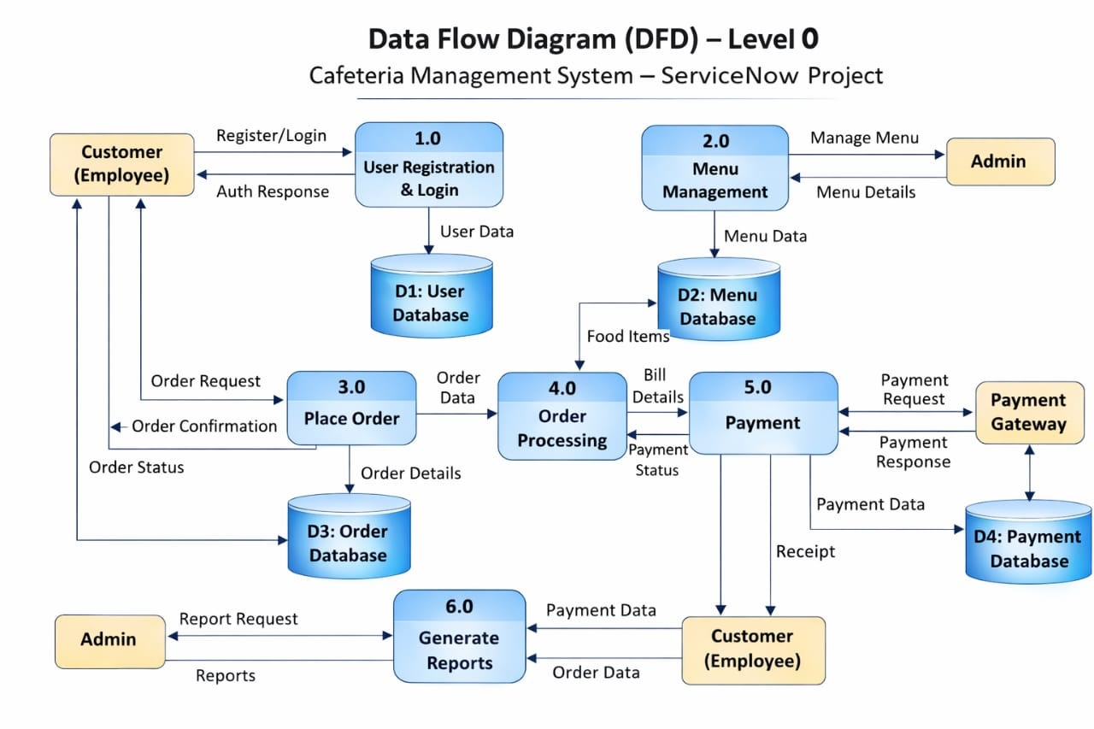


User Stories
Use the below template to list all the user stories for the product.
User Type | Functional Requirement (Epic) | User Story Number | User Story / Task | Acceptance criteria | Priority | Release
Customer (Web user) | Registration | USN-1 | As a user, I can register for the application by entering my email, password, and confirming my password. | Account is created successfully and user receives confirmation message | High | Sprint-1
Customer (Web user) | Registration | USN-2 | As a user, I will receive a confirmation notification after successful registration. | System displays success message after registration. | High | Sprint-1
Customer (Web user) | Login | USN-3 | As a user, I can log into the application using email and password. | User is redirected to dashboard after successful login. | High | Sprint-2
Customer (Web user) | Dashboard | USN-4 | As a user, I can view available cafeteria menu items. | Menu list is displayed with menu name, items, price, and status. | Medium | Sprint-2
Customer (Web user) | Dashboard | USN-5 | As a user, I can view only Published menu items. | Only menus where status = Published are visible. | Medium | Sprint-2
Administrator | Menu Creation | USN-6 | As an admin, I can create a new cafeteria menu record. | Menu record is saved successfully in the table. | High | Sprint-1
Administrator | Menu Update | USN-7 | As an admin, I can update cafeteria menu details. | Updated values are saved correctly. | Medium | Sprint-2
Administrator | Menu Publish | USN-8 | As an admin, I can mark a menu as Published using UI Action. | Status changes to Published and confirmation message is shown. | High | Sprint-1
Administrator | Menu Delete | USN-9 | As an admin, I can delete unwanted menu records. | Selected record is deleted from the system. | Medium | Sprint-2
Executive / Manager | reporting | USN-10 | As a manager, I can view cafeteria menu reports. | Report shows list of menus and their status. | Low | Sprint-3

